# CS 255 System Design Document Template

This template lays out all the different sections that you need to complete for Project Two. Each section has guidance to prompt your thinking. You will need to continually reference the interview transcript as you work to make sure that you are addressing your client’s needs. There is no required length for the final document. Instead the goal is to complete each section based on what your client’s needs are. Remove this note when you are finished, and replace all bracketed text with the relevant information.

## UML Diagrams

### UML Use Case Diagram

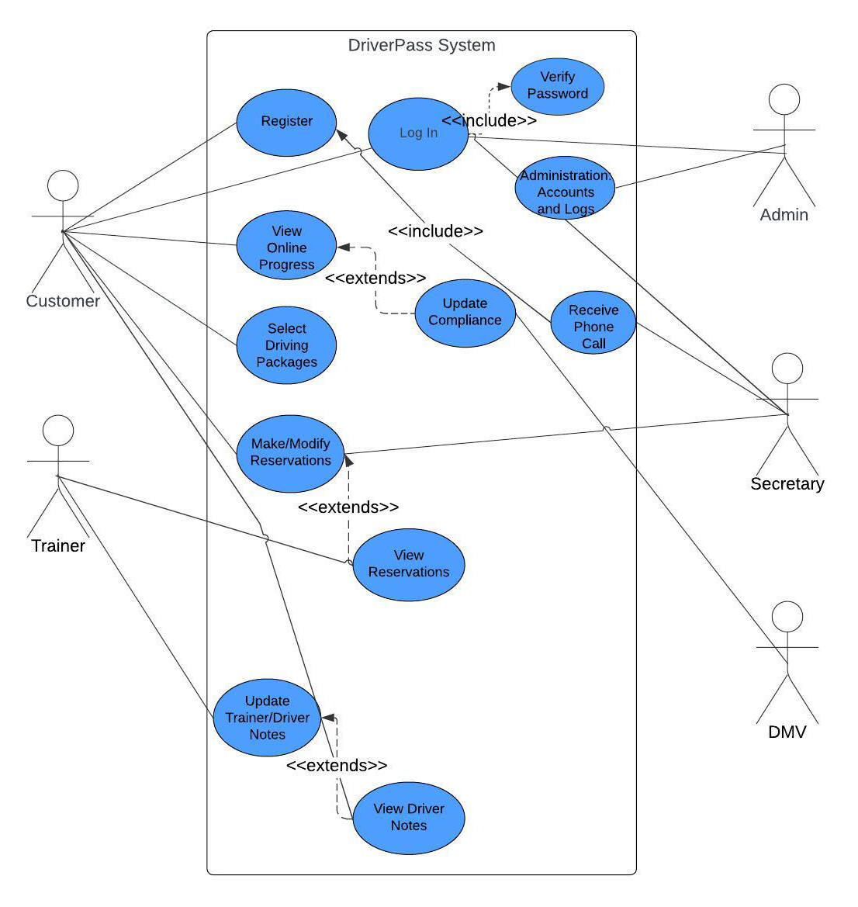

### UML Activity Diagrams

*Login Activity Diagram*

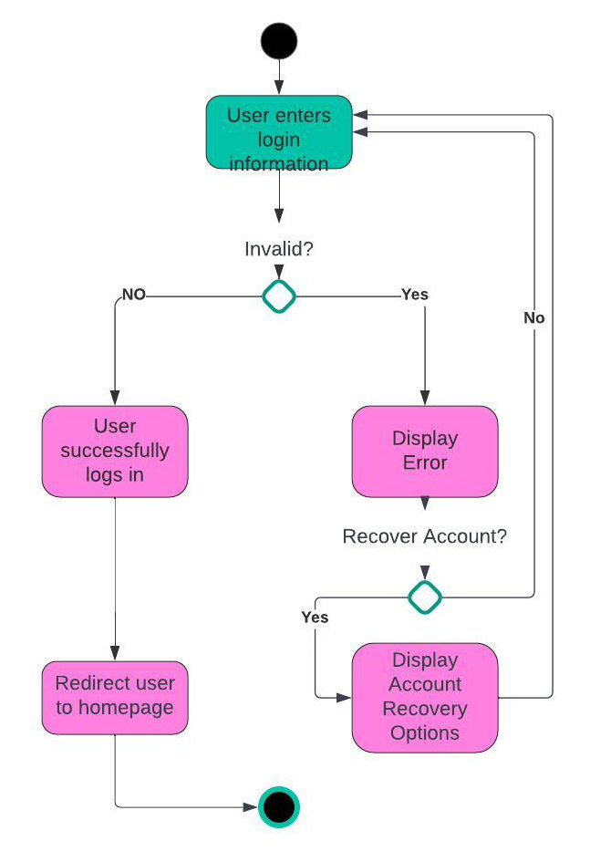

Select Driving Packages Activity Diagram

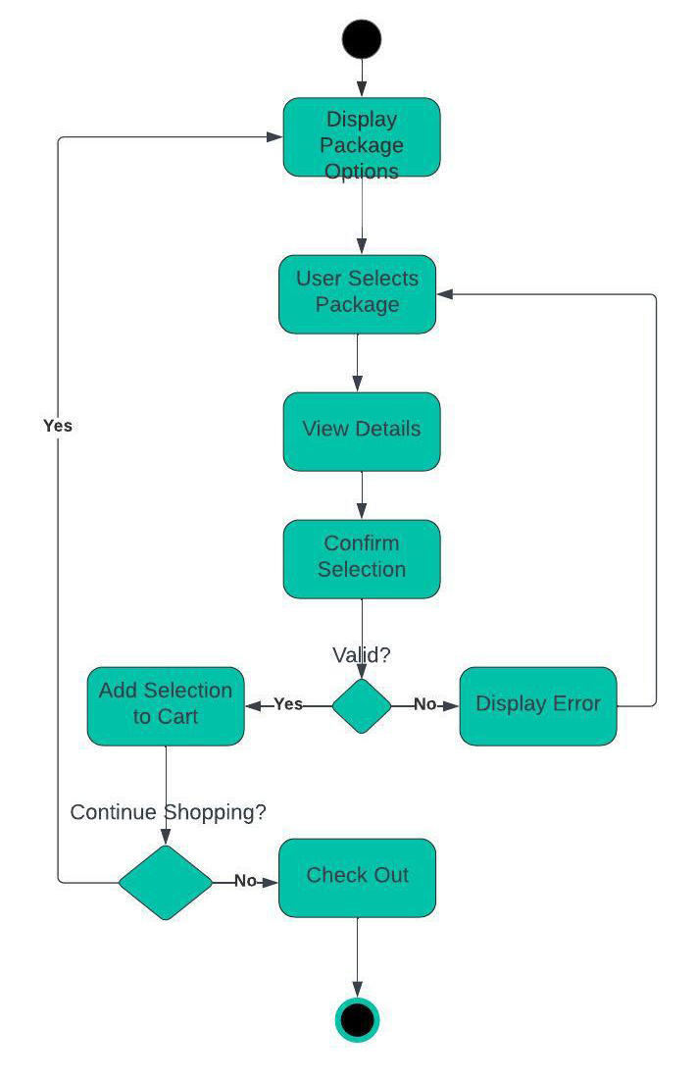

### UML Sequence Diagram

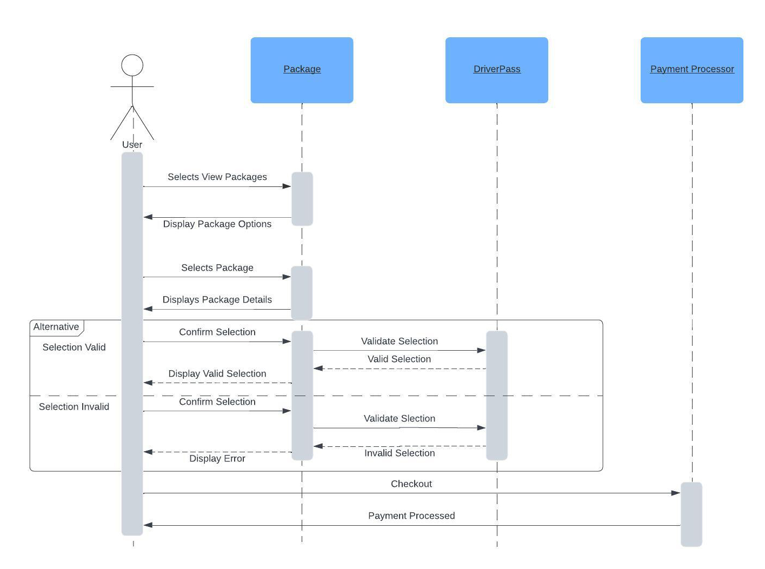

### UML Class Diagram

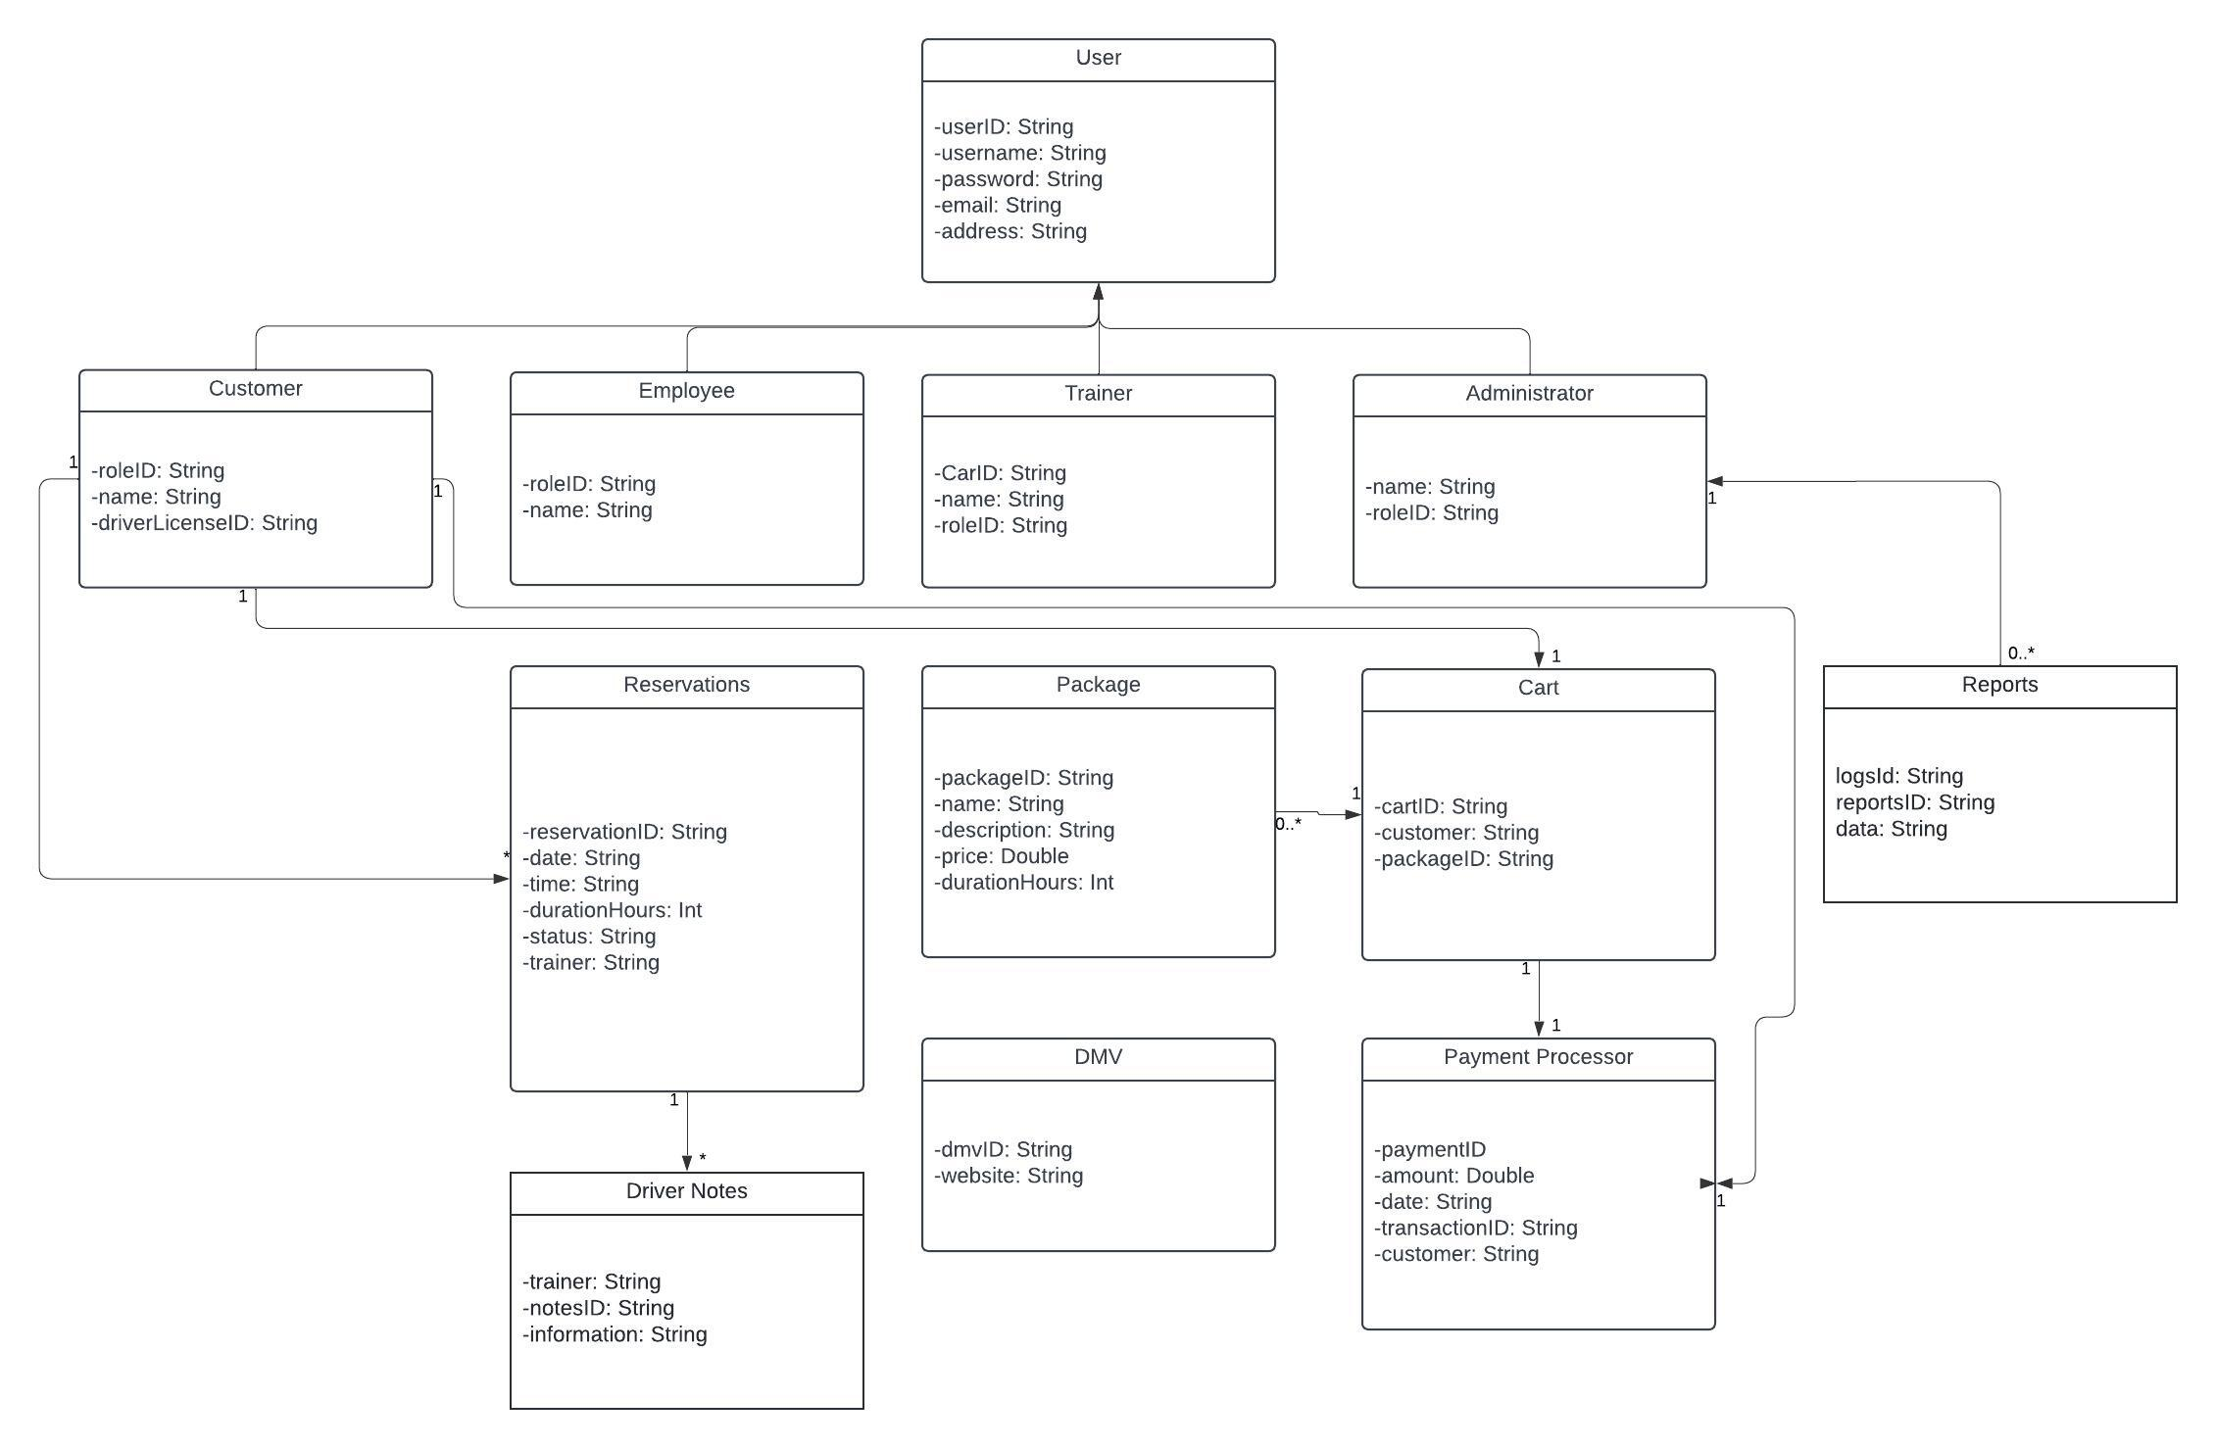

## Technical Requirements

*[Based on the diagrams you have created, describe the technical requirements of your system. These requirements should address the required hardware, software, tools, and infrastructure necessary for your system design.]*

*Required Hardware:*

* *Servers that implement a cloud-based architecture for security and adaptable for future growth.*
* *Mobile device that are using current Ios or Android operating systems to access our system*
* *Computers with compatible WEB browsers to access our system.*

*Software:*

* *Ios or Andriod Operating systems for mobile*
* *MacOS, Linux or Windows operating systems for personal computers.*
* *Microsoft Edge, Chrome, Firefox, Safari web browsers for testing.*
* *Development Platforms such as Visual Studio, IntelliJ, Android Studio, Swift*
* *Database system such as MySQL to store data*

*Tools:*

* *Project Management Software to help streamline development*
* *IDE licenses to develop for various platforms*

*Infrastructure:*

* *Cloud based hosting such as Azure, Google or AWS.*